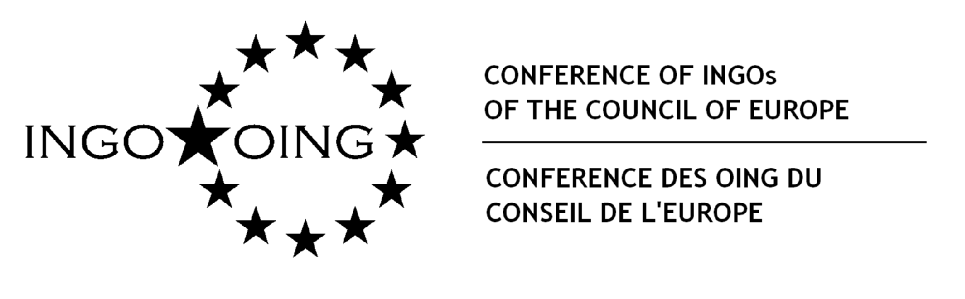

CIVIL SOCIETY FORUM

Living Together
Combining diversity and freedom in 21st -century Europe

Strasbourg, 13-14 November 2011

Application form
My NGO is interested in participating in the Civil Society Forum and suggests the following candidate :
Title (Mr, Mrs, Ms) ………………………………………………………………………
First name ……………………………… Family name ………………………………….
Function:
Organisation and country :
Postal address :

Telephone and mobile:
Fax:
Email:

Working languages (proficiency is required in at least one of the working languages, English or French  English French

Please provide a brief description of your organisation and its objectives

Which workshop would you like to participate in?

First set of parallel thematic workshops on “Making Policy”

 Workshop 1 a Diversity and education

 Workshop 2 a Diversity and social cohesion

Second set of parallel thematic workshops on “Making Policy Work”

 Workshop 1 b Diversity and education

 Workshop 2 b Diversity and social cohesion

Describe briefly the activities undertaken by your NGO in the area covered by the workshop you have chosen

How could your NGO benefit from your participation in the Forum?

50 civil society representatives will be selected through this call for applications. The Council of Europe will cover travel and subsistence expenses.

Name and position of the person submitting the application:

Kindly return this form to Mrs Catherine Emezie by email: catherine.emezie@coe.int
by 9 september 2011 at the latest. Selected NGOs will be informed by end of September 2011.

Please fill form in English only
If your organisation has more than one address, please provide the address of where you are located

